**Lauren Pelayo**

**Thomas Lindholm**

**Alex Lundin**

PHYS 2125.104.603

TA: Mathew Fong

Oct. 10, 2015

**Lab 5: Newton’s Second Law**

**Table of Contents**

1. **Analysis**
2. **Data**
3. **Calculations**
4. **Analysis**

**(Q1)** There are two bodies in the system, the hanger $h$ and the glider $G.$ The hanger pulled the glider in the +x direction. The hanger has two forces acting on it: its weight and the tension T exerted by the string on the hanger. As for the glider, there are three forces acting on it: its weight, the tension T exerted by the string on the glider, and the force the surface exerts on the glider.

$Glider: ΣF_{x}=T-f, ΣF_{Y}=F_{N}-w_{g}=0$

$Hanger: ΣF_{x}=0 ΣF_{y}=w_{h}-T$

GliderHanger

X: $ΣF_{x}=T-f=m_{atg}a$ $ΣF_{y}=w_{h}-T$

Y: $ΣF_{y}=F_{n}-w_{g}=0$ $ΣF_{x}=0$

**(Q2) $ΣF_{y}=w_{h}-T=m_{h}a$ $→$ $T=w_{h}-m_{g}a=m_{h}g-m_{h}a$**

$ΣF_{x}=T-f=m_{atg}a$ $→$ $m_{h}g-m_{h}a-f=m_{atg}a$ $→$ $a=\frac{m_{h}g-f}{m_{atg}+m_{h}}$

**(Q3) $a=\frac{m_{h}g}{m_{atg}+m_{h}}$**

**(Q4)** 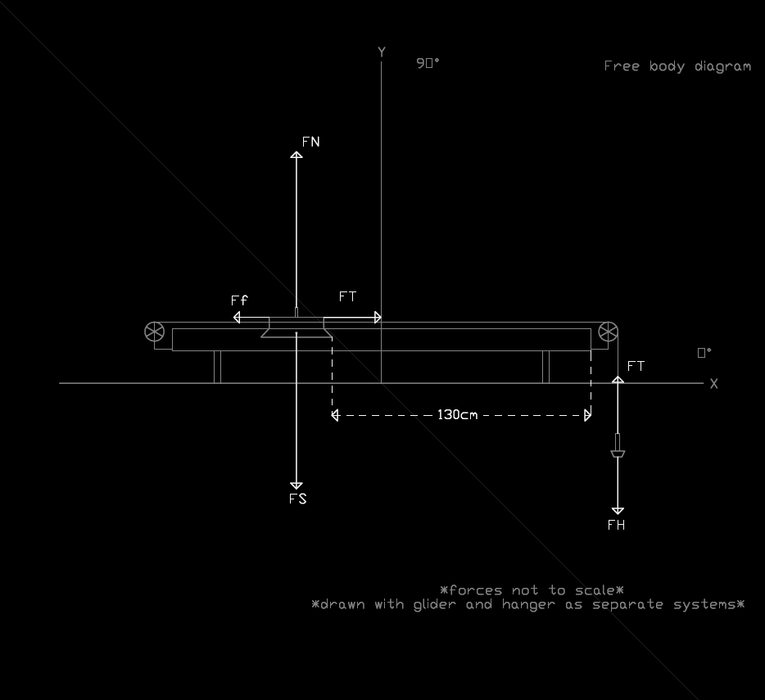

**(Q5) $Gravity > a=\frac{m_{h}g}{m_{atg}+{ m_{h}}_{ }}(f=0) > a=\frac{m_{h}g-f}{m_{atg}+m_{h}}(f≠0)$**

**5.1 Part 1: Using Computer**

**(Q1)**

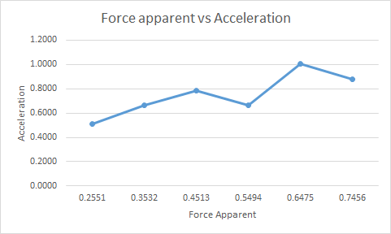

**(Q2)**

Yes, the graph must be linear. This can be proven with the expression we got for our acceleration, ignoring friction: $a=\frac{m_{h}g}{m_{atg}+m_{h}}$

We also know that $F_{app}=m_{h}∙g.$ We want to find the relationship between acceleration and force of application so we substitute in $F_{app}$ into our acceleration expression we get,

$a=\frac{m_{h}g}{m_{atg}+m_{h}}=\frac{F_{app}}{m_{atg}+m_{h}}={\frac{F_{app}}{m_{total}}}_{}$

**(Q3)**

The slope represents the total system mass, as shown by manipulated our expression.

$a=\frac{F_{app}}{m_{total}}$ $→$ $F_{app}=m_{total}∙a$

**(Q4)**

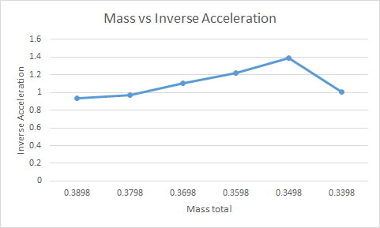

**(Q5)**

$a=\frac{F_{app}}{m_{total}}$ $→$ $m_{total}=F_{app}∙\frac{1}{a}$

After rearranging our expression of acceleration from before, we find that relationship between the inverse of acceleration and total mass is indeed linear. As total mass increases,

the acceleration decreases. Although it is an inverse relationship, it is still a linear relationship.

**(Q6)**

In this case, the slope represents $F_{app}$ as shown by our expression above.

**(Q7)**

|  |  |  |  |
| --- | --- | --- | --- |
| Trial | Slope | Total Mass | % Difference |
| 1 | 0.3670 | 0.4595 | 25.20 |
| 2 | 0.3670 | 0.4595 | 25.20 |
| 3 | 0.3670 | 0.4595 | 25.20 |
| 4 | 0.3670 | 0.4595 | 25.20 |
| 5 | 0.3670 | 0.4595 | 25.20 |
| 6 | 0.3670 | 0.4595 | 25.20 |

$F_{app}$ vs Acceleration Graph

|  |  |  |  |
| --- | --- | --- | --- |
| Trial | Slope | $F_{app}$ | % Difference |
| 1 | 0.3467 | 0.4537 | 30.86 |
| 2 | 0.3467 | 0.4537 | 30.86 |
| 3 | 0.3467 | 0.4537 | 30.86 |
| 4 | 0.3467 | 0.4537 | 30.86 |
| 5 | 0.3467 | 0.4537 | 30.86 |
| 6 | 0.3467 | 0.4537 | 30.86 |

Total System Mass vs Inverse of Acceleration

**(Q8)**

We do expect the results to be the same in the last two columns for Table 1 and 2 because $\frac{1}{a}=\frac{m_{total}}{F_{app}} → F_{app}=m_{total}∙a$

**(Q9)**

|  |  |  |  |
| --- | --- | --- | --- |
| Trial | $F_{app}$ | $m_{total}∙a$ | % Difference |
| 1 | 0.2548 | 0.2530 | 0.7064 |
| 2 | 0.3528 | 0.3067 | 13.07 |
| 3 | 0.4508 | 0.3597 | 20.21 |
| 4 | 0.5488 | 0.3067 | 44.11 |
| 5 | 0.6402 | 0.4609 | 28.01 |
| 6 | 0.7448 | 0.4040 | 45.76 |

Constant Total Mass

|  |  |  |  |
| --- | --- | --- | --- |
| Trial | $F_{app}$ | $m_{total}∙a$ | % Difference |
| 1 | 0.4537 | 0.4175 | 7.979 |
| 2 | 0.4537 | 0.3920 | 13.60 |
| 3 | 0.4537 | 0.3361 | 25.92 |
| 4 | 0.4537 | 0.2944 | 35.11 |
| 5 | 0.4537 | 0.2519 | 44.48 |
| 6 | 0.4537 | 0.3373 | 25.66 |

Changing Total Mass

**(Q10)**

One possible error in this experiment could air resistance, which could cause a decrease in acceleration.

**Part 2: Using Stopwatch**

**(Q1)**

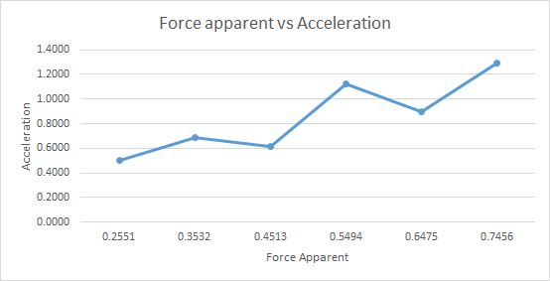

**(Q2)**

The data should be linear and although our data is not perfectly linear, due to external errors, it still satisfies the theory as the R² value is still fairly high and close to 1. Once again, if we substitute $F_{app}$ for $m_{h}∙g$ because we know they are equal to each other, we get the following

$a=\frac{m_{h}g}{m_{atg}+m_{h}}=\frac{F_{app}}{m_{atg}+m_{h}}=\frac{F_{app}}{m_{total}} → F_{app}=m_{total}∙a$

**(Q3)**

The slope of this graph represents the total mass of the system, as shown in the equation above.

**(Q4)**

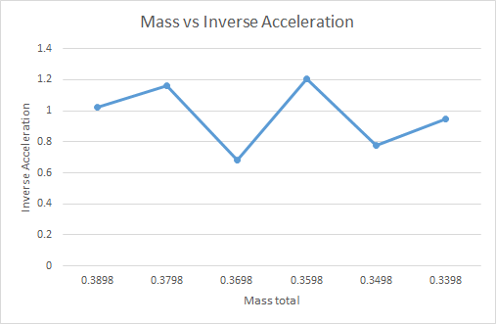

**(Q5)**

Yes, the graph should be linear. After rearranging our previous equation, we would get

$F_{app}=m_{total}∙a → m_{total}=\frac{F_{app}}{a}$

The total mass and the inverse of acceleration has an inverse linear relationship. As acceleration increases total mass should decrease.

**(Q6)**

The slope should represent $F_{app}$

**(Q7)**

|  |  |  |  |
| --- | --- | --- | --- |
| Trial | Slope | Total Mass | % Difference |
| 1 | 0.4233 | 0.4595 | 8.552 |
| 2 | 0.4233 | 0.4595 | 8.552 |
| 3 | 0.4233 | 0.4595 | 8.552 |
| 4 | 0.4233 | 0.4595 | 8.552 |
| 5 | 0.4233 | 0.4595 | 8.552 |
| 6 | 0.4233 | 0.4595 | 8.552 |

$F_{app}$ vs Acceleration

|  |  |  |  |
| --- | --- | --- | --- |
| Trial | Slope | $F_{app}$ | % Difference |
| 1 | 0.0958 | 0.4542 | 374.1 |
| 2 | 0.0958 | 0.4542 | 374.1 |
| 3 | 0.0958 | 0.4542 | 374.1 |
| 4 | 0.0958 | 0.4542 | 374.1 |
| 5 | 0.0958 | 0.4542 | 374.1 |
| 6 | 0.0958 | 0.4542 | 374.1 |

Total System Mass vs Inverse of Acceleration

**(Q8)**

Yes, the last two columns in the previous two tables should be the same as shown by

$F_{app}=m_{total}∙a$

**(Q9)**

|  |  |  |  |
| --- | --- | --- | --- |
| Trial | $F_{app}$ | $m_{total}∙a$ | % Difference |
| 1 | 0.2551 | 0.2298 | 9.90% |
| 2 | 0.3532 | 0.3142 | 11.04% |
| 3 | 0.4513 | 0.2815 | 37.61% |
| 4 | 0.5494 | 0.5171 | 5.87% |
| 5 | 0.6475 | 0.4134 | 36.15% |
| 6 | 0.7456 | 0.5925 | 20.53% |

Constant Mass

|  |  |  |  |
| --- | --- | --- | --- |
| Trial | $F_{app}$ | $m_{total}∙a$ | % Difference |
| 1 | 0.4542 | 0.3815 | 16.02% |
| 2 | 0.4542 | 0.3262 | 28.19% |
| 3 | 0.4542 | 0.5435 | 19.67% |
| 4 | 0.4542 | 0.2986 | 34.26% |
| 5 | 0.4542 | 0.4510 | 0.70% |
| 6 | 0.4542 | 0.3584 | 21.09% |

Changing Mass

**(Q10)**

Possible sources of error would be the same as in the previous section- the reaction time. Anticipating when to stop the timer would cause the time to be lower, and thus a higher acceleration. This would then result in a higher value for $m_{total}∙a.$ A way to help reduce this error is to have the person holding the timer close their eyes and place their hands on the floor where the hanger

will land. Another way to improve is to use a better instrument that could measure the exact time the hanger takes to touch the ground.

**2.) Data**

|  |  |  |  |  |  |  |
| --- | --- | --- | --- | --- | --- | --- |
| Trial | $m_{atg} (kg)$ | $m_{h} (kg)$ | $m_{total} (kg)$ | $a (slope) (m/s^{2})$ | $F_{app}=m_{h}∙g (N)$ | $m_{total}∙a (N)$ |
| 1 | 0.4335 | 0.0260 | 0.4595 | 0.5114 | 0.2548 | 0.2350 |
| 2 | 0.4235 | 0.0360 | 0.4595 | 0.6675 | 0.3528 | 0.3067 |
| 3 | 0.4135 | 0.0460 | 0.4595 | 0.7827 | 0.4508 | 0.3587 |
| 4 | 0.4035 | 0.0560 | 0.4595 | 0.6675 | 0.5488 | 0.3067 |
| 5 | 0.3935 | 0.0660 | 0.4595 | 1.003 | 0.6402 | 0.4609 |
| 6 | 0.3835 | 0.0760 | 0.4595 | 0.8792 | 0.7748 | 0.4040 |

Table 1: Data table for constant total mass using computer

|  |  |  |  |  |  |  |
| --- | --- | --- | --- | --- | --- | --- |
| Trial | $m_{atg} (kg)$ | $m_{h} (kg)$ | $m_{total} (kg)$ | $a (slope) (m/s^{2})$ | $F_{app}=m_{h}∙g (N)$ | $m_{total}∙a (N)$ |
| 1 | 0.3435 | 0.0463 | 0.3898 | 1.071 | 0.4537 | 0.4175 |
| 2 | 0.3335 | 0.0463 | 0.3798 | 1.052 | 0.4537 | 0.3920 |
| 3 | 0.3235 | 0.0463 | 0.3698 | 0.9919 | 0.4537 | 0.3361 |
| 4 | 0.3125 | 0.0463 | 0.3598 | 0.8183 | 0.4537 | 0.2944 |
| 5 | 0.3035 | 0.0463 | 0.3498 | 0.7208 | 0.4537 | 0.2519 |
| 6 | 0.2935 | 0.0463 | 0.3398 | 0.9936 | 0.4537 | 0.3373 |

Table 2: Data table for constant hanger mass using computer

|  |  |  |  |  |  |  |  |
| --- | --- | --- | --- | --- | --- | --- | --- |
| Trial | $m_{atg} (kg)$ | $m_{h} (kg)$ | $m_{total} (kg)$ | $t (s)$ | $a (m/s^{2})$ | $F_{app}=m_{h}∙g (N)$ | $m_{total}∙a (N)$ |
| 1 | 0.4335 | 0.0260 | 0.4595 | 2.280 | 0.5002 | 0.2548 | 0.2298 |
| 2 | 0.4335 | 0.0360 | 0.4595 | 1.950 | 0.6838 | 0.3528 | 0.3142 |
| 3 | 0.4335 | 0.0460 | 0.4595 | 2.060 | 0.6127 | 0.4508 | 0.2818 |
| 4 | 0.4335 | 0.0560 | 0.4595 | 1.520 | 1.125 | 0.5488 | 0.5169 |
| 5 | 0.4335 | 0.0660 | 0.4595 | 1.700 | 0.8997 | 0.6468 | 0.4134 |
| 6 | 0.4335 | 0.0760 | 0.4595 | 1.420 | 1.289 | 0.7448 | 0.5923 |

Table 3: Data table for constant total mass using stopwatch

|  |  |  |  |  |  |  |  |
| --- | --- | --- | --- | --- | --- | --- | --- |
| Trial | $m_{atg} (kg)$ | $m_{h} (kg)$ | $m_{total} (kg)$ | $t (s)$ | $a (m/s^{2})$ | $F_{app}=m_{h}∙g (N)$ | $m_{total}∙a (N)$ |
| 1 | 0.3435 | 0.0463 | 0.3898 | 1.630 | 0.9786 | 0.4537 | 0.3815 |
| 2 | 0.3335 | 0.0463 | 0.3878 | 1.740 | 0.8588 | 0.4537 | 0.3252 |
| 3 | 0.3235 | 0.0463 | 0.3698 | 1.330 | 1.470 | 0.4537 | 0.5436 |
| 4 | 0.3135 | 0.0463 | 0.3598 | 1.770 | 0.8299 | 0.4537 | 0.2986 |
| 5 | 0.3035 | 0.0463 | 0.3498 | 1.420 | 1.289 | 0.4537 | 0.4509 |
| 6 | 0.2935 | 0.0463 | 0.3398 | 1.570 | 1.055 | 0.4537 | 0.3585 |

Table 4: Data table for constant hanging mass using stopwatch

**3.) Calculations**

Example calculations taken from 5.1 question 7:

$\% difference=\frac{\left|slope-total mass\right|}{slope}∙100=\frac{\left|0.3670-0.4595\right|}{0.3670}=25.20\%$

$\% difference=\frac{\left|slope-F_{app}\right|}{slope}∙100=$ $\frac{\left|0.3467-0.4537\right|}{0.3467}=30.86\%$

Example equations taken from Table 1:

$F_{app}=m_{h}∙g$

$F_{app}=0.0260∙9.8=0.2548$

$m_{total}∙a=$

$0.4595∙0.5114=0.2350$